**Instruction:**

Complete all questions in **1 hour.**

1. What is flip flop? Describe the working mechanism RS flip flop.

Flip-flop is a type of circuit in which a single bit of data either 1 or 0 is stored.

When output is 0 and 1 the flip flop is rest and if 1 and 0 the flip-flop is set.

When REST and SET input both are 1, the output depends on type of RS filp flop.

1. Construct the timing diagram for half adder and half subtractor, full adder.

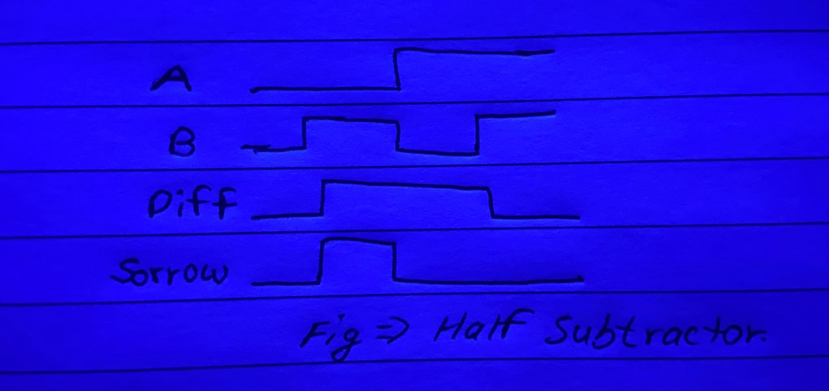



1. Describe the working mechanism of 4-bit register by constructing the circuit using D flip flop.

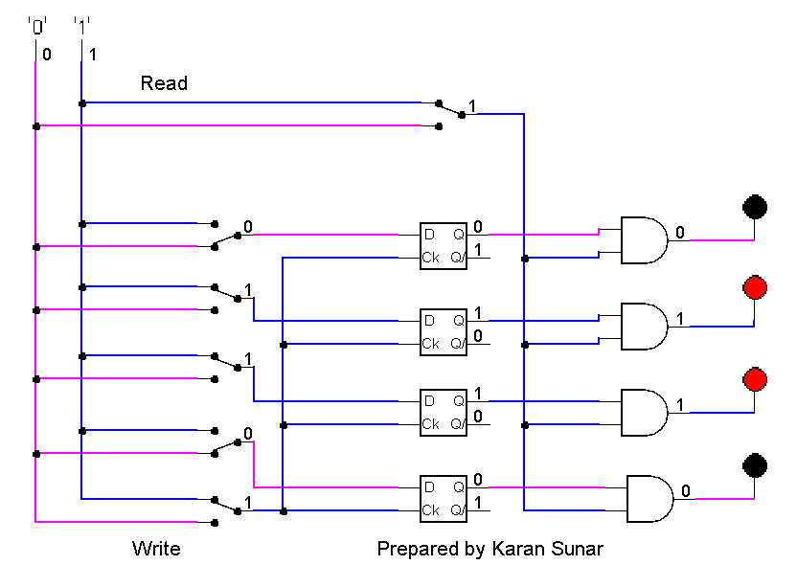

4. Differentiate between:

a) Flip flop and Latch

Flip flop is a circuit where the state changes when a input signal goes high to low or low to high whereas latch changes output as soon as the input changes.

b) Combinational circuit and Sequential circuit

Combinational circuits, a time-independent, output does not depend on any of its previous inputs whereas Sequential circuits are the ones that depend on clock cycles.

c) SIPO and PISO

Shift register SIPO is loaded with serial data and the stored data is being available at the output in parallel form whereas PISO is loaded data simultaneously and the stored data is shifted out serially one bit at a time under clock control.